FRESH BITES CATERING

PROJECT REPORT

INTRODUCTION:

OVERVIEW:

With the help of ZohoBooks of account we created profit and loss account and balance sheet and GST(18%) calculation for the fresh bites catering

PURPOSE:

It is created for the purpose of prepare profit and loss account,balance sheet and prepare GST report for the fresh bites catering.

PREPARATION AND MAINTANENCE OF ZOHO BOOKS FOR FRESH BITES CATERING

Fresh bites catering,a catering service,utilizes zoho books to manage their sales,track inventory ,and handle invoicing. Then can generate professional invoice for clients and track expences related to ingredients and supplies.zoho books help them maimtance accurate financial records and streamline there catering operations.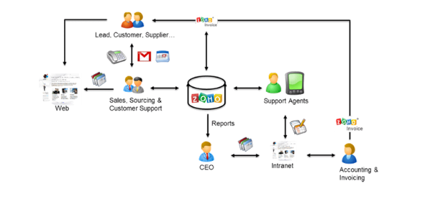

PROBLEM DEFINITION & DESIGN THINKING:

It is created method of preparation of accouting profit and loss account,balance sheet and GSTcalculation is complicated.

It recent days new technologies allotted.here we use Zohobook as a tool for creating profit and loss account,balance sheet and GST report.

EMPATHY MAP: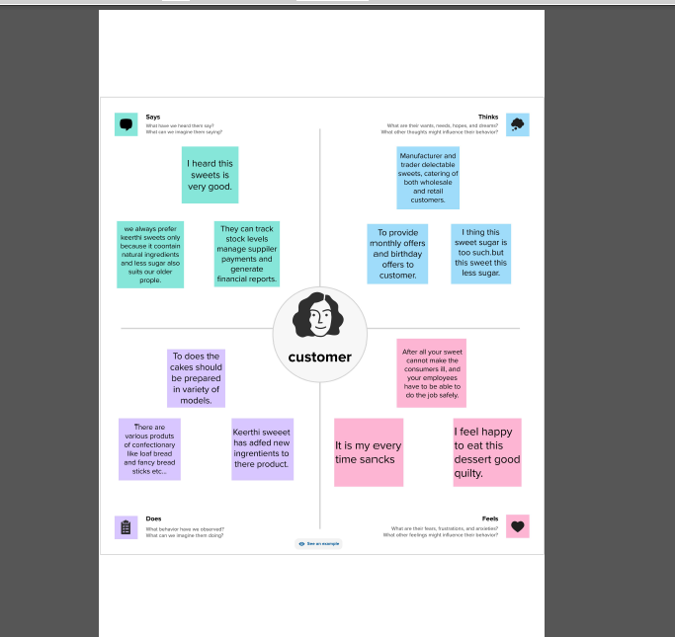

IDEATION & BRAINSTORMING MAP: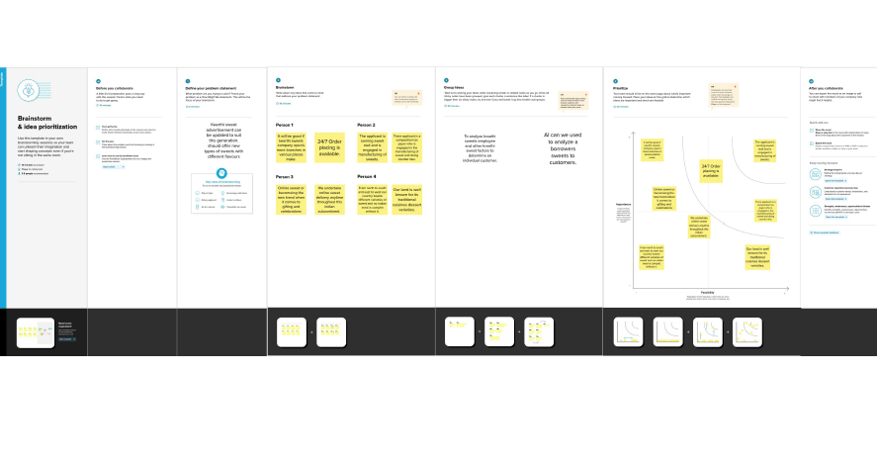

RESULT:

OUTPUT:

COMPANY NAME CREATION:

We have to create an company name and other details from below zohobooks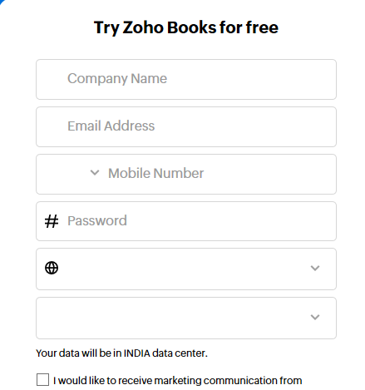

ITEM NAME

UNITS

HSN/SAC

SELLING INFO/ PURCHASE INFO

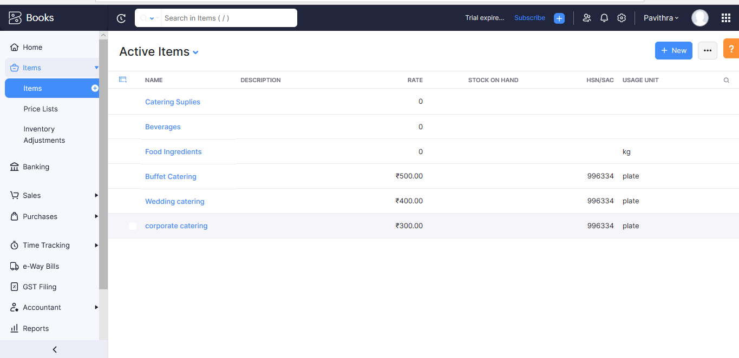

VENDOR CREATION:

Now create vendor in books from navigator panel created new vendor for example

MEGA STORE SUPPLIES

WHOLE FOODS MARKET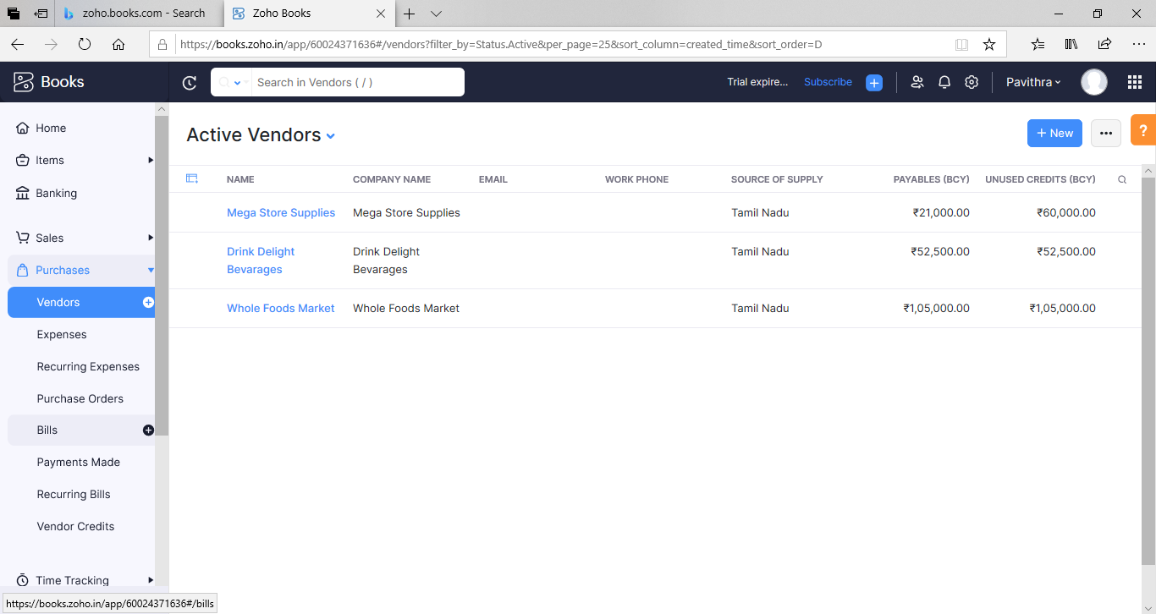

PURPOSE ORDER:

We creating new purchase order such as belows.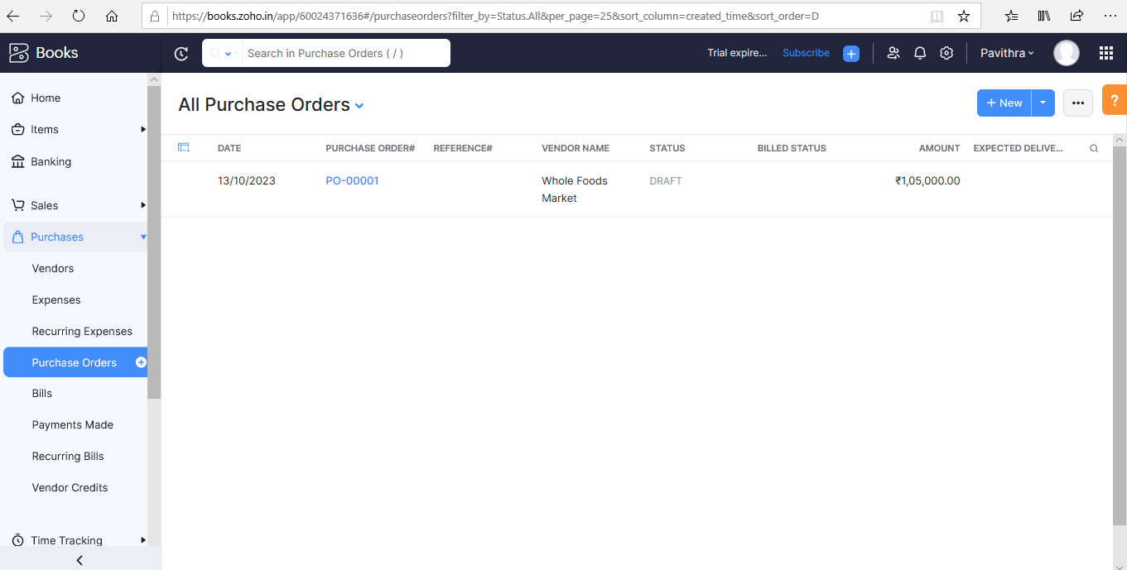

SALES ORDER:

Mega Store Supplies received belows sales order from mentioned customer.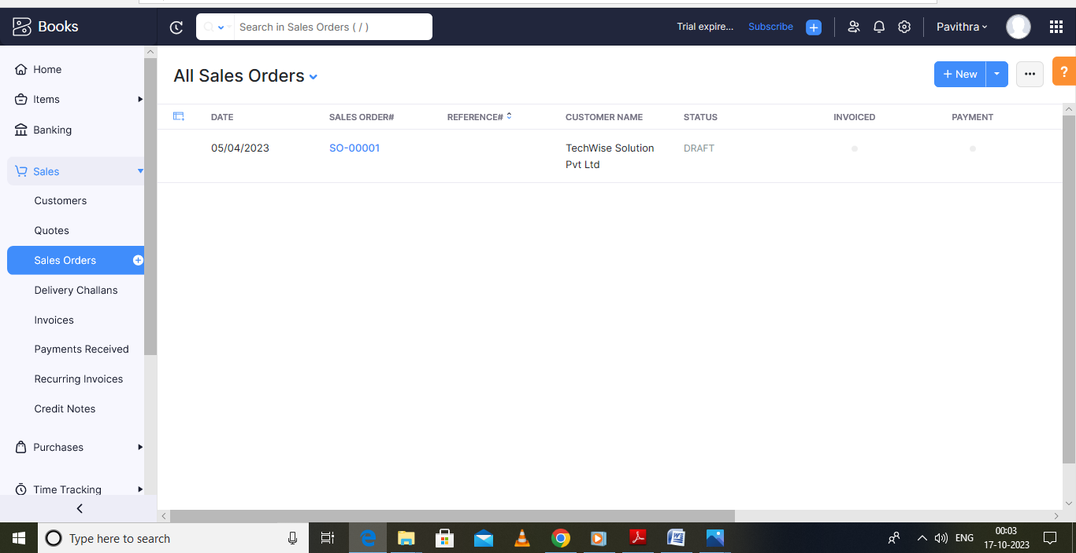

PAYMENT TO BANK DETAILS:

Mega store supplies has opened an account with ICICI bank, to add the bank account and we have to select bank account manually and filled it.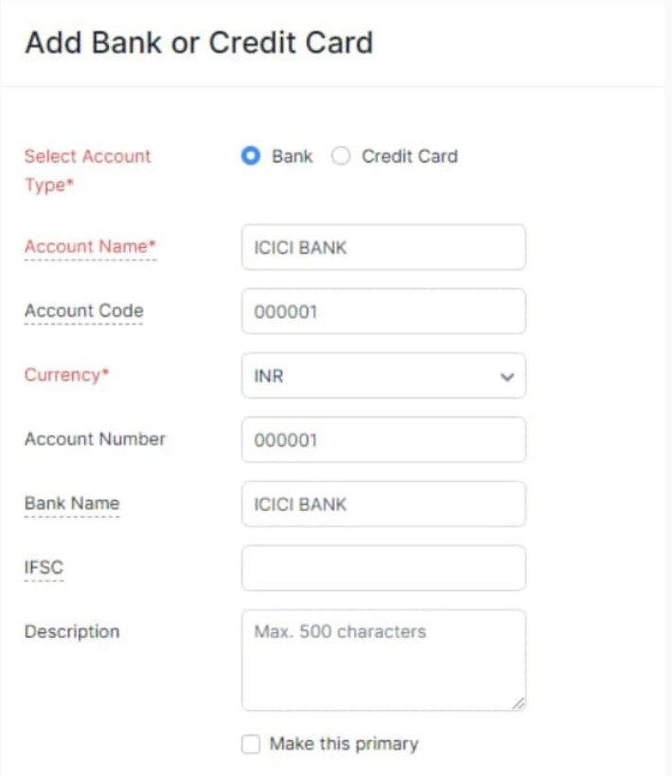

PROFIT AND LOSS ACCOUNT: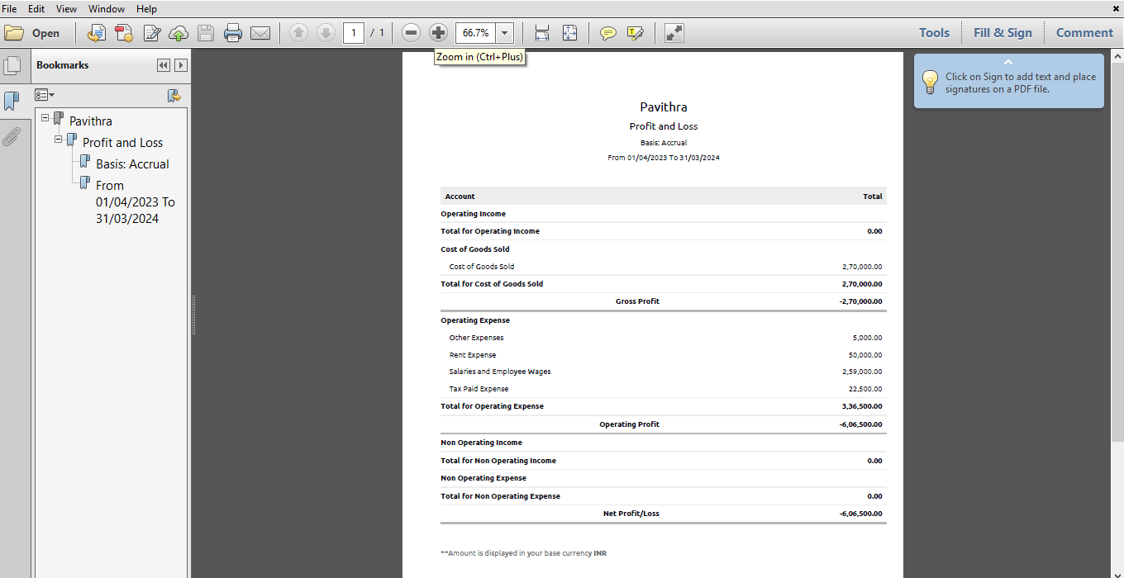

BALANCE SHEET: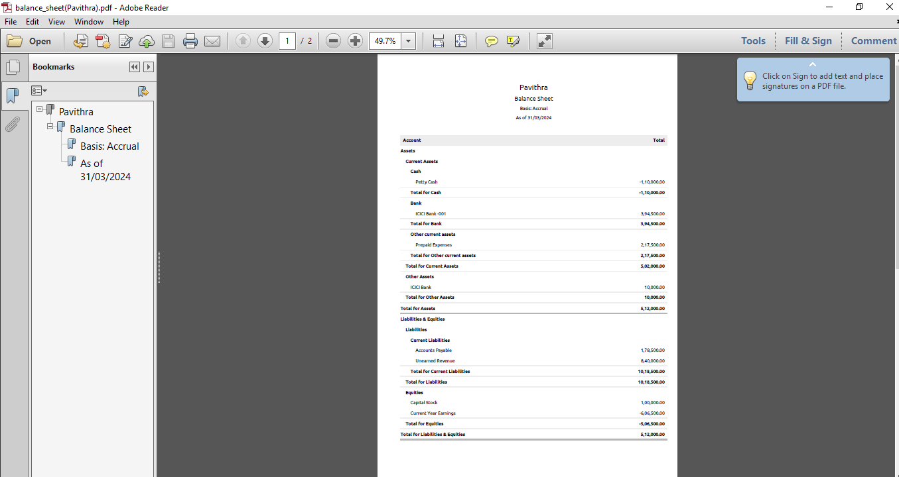

GST REPORT: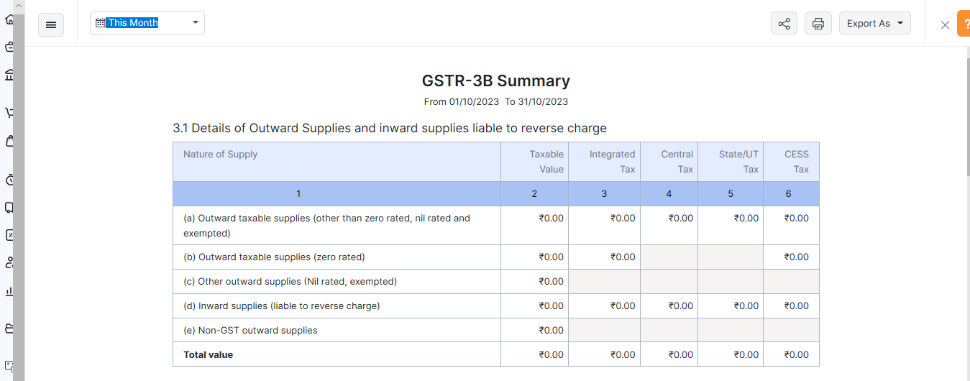

ADVANTAGES & DISADVANTAGES:

ADVANTAGES

Catering Food Will Help You Throw an Amazing Party .

Expanses and tracking.

DISADVANTAGES

It will be difficult in the beginning of your Career.

Time tracking must be tied to project.

Difficult to modify bills.

APPLICATION:

This applications used to maintain the company details and ledger accounts, profit and loss account and balance sheet of the company mega store supplies.

CONCLUSION:

It is a service that DELIVERS,COOKS and SARVES FOOD on side at a clients location.

FUTURE SCOPE:

Preparing and storing food safety before during events. Setting up all tablets and food service areas with Charis, lines and dishes, serving food to guests at events. It also helped to reduce the work of the accountant to maintain accounts.

APPENDIX:

Approved development

Future assessment

Pain of Development

Convactless Free Delivery and Pickup.

Team19 https://githup.com/mtu121ucom041/preparation-and-maintenance-of-ZOHO-BOOKS-for-keerthi-sweets/commit/4c17cabde896b9a4333ebf9012611a19d506f439s